Infix

What is Infix
# Source: AI Source: Provided by: [Data Path: Persons Table -> ID Column: 1, Name_En Column: Motasem Essam] -> From: [Chatgpt (GPT-4-turbo)] on [7/29/2025]
An infix is a type of affix that is inserted within a root or word, rather than at the beginning or end. Infixation is rare in English but common in several other languages, especially in Austronesian and Southeast Asian languages.

🔹 Definition of Infix:
# Source: AI Source: Provided by: [Data Path: Persons Table -> ID Column: 1, Name_En Column: Motasem Essam] -> From: [Chatgpt (GPT-4-turbo)] on [7/29/2025]
An infix is a bound morpheme that is inserted inside a root or stem to modify its meaning or grammatical form. Unlike prefixes and suffixes, which are attached at the edges, infixes are embedded within the word itself.

🔹 Examples of Infixes:

1. In Other Languages (Productive Use):
# Source: AI Source: Provided by: [Data Path: Persons Table -> ID Column: 1, Name_En Column: Motasem Essam] -> From: [Chatgpt (GPT-4-turbo)] on [7/29/2025]
- Tagalog (Philippines):
  - Root: sulat ("write")
  - Infix: -um-
  - Word: sumulat ("wrote")
- Bontoc (Philippines):
  - Root: fikas ("strong")
  - Infix: -um-
  - Word: fumikas ("to be strong")

2. In English (Rare & Informal Use):
# Source: AI Source: Provided by: [Data Path: Persons Table -> ID Column: 1, Name_En Column: Motasem Essam] -> From: [Chatgpt (GPT-4-turbo)] on [7/29/2025]
English doesn't use infixes in a grammatical or productive way, but it has expletive infixation in informal or emphatic speech:
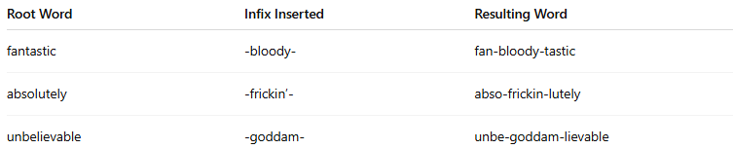
Root Word | Infix Inserted | Resulting Word
fantastic | -bloody- | fan-bloody-tastic
absolutely | -frickin’- | abso-frickin-lutely
unbelievable | -goddam- | unbe-goddam-lievable
These are not standard or grammatical, but they show expressive/emphatic uses of infixes in English.

🔹 Features of Infixes:
# Source: AI Source: Provided by: [Data Path: Persons Table -> ID Column: 1, Name_En Column: Motasem Essam] -> From: [Chatgpt (GPT-4-turbo)] on [7/29/2025]
- ✅ Inserted inside the root (not at the ends).
- ✅ Productive in non-Indo-European languages.
- ❌ Rare in English; used only playfully or emotionally.
- ✅ Can carry grammatical or emphatic meaning depending on the language.
- ✅ Found in Austronesian, Sino-Tibetan, and Niger-Congo languages.

🔹 Infix vs Other Affixes:
# Source: AI Source: Provided by: [Data Path: Persons Table -> ID Column: 1, Name_En Column: Motasem Essam] -> From: [Chatgpt (GPT-4-turbo)] on [7/29/2025]
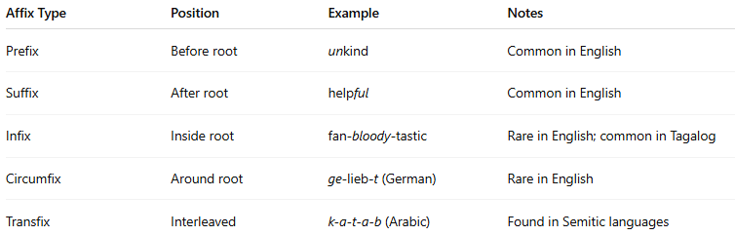
Affix Type | Position | Example | Notes
Prefix | Before root | unkind | Common in English
Suffix | After root | helpful | Common in English
Infix | Inside root | fan-bloody-tastic | Rare in English; common in Tagalog
Circumfix | Around root | ge-lieb-t (German) | Rare in English
Transfix | Interleaved | k-a-t-a-b (Arabic) | Found in Semitic languages

